**School Supplies for 2016-17**

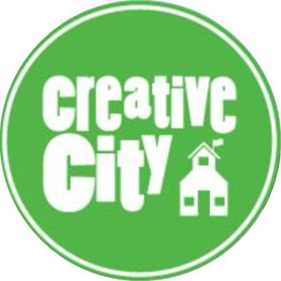

For the 2016-17 school year, Creative City will provide students with the needed at-school supplies to ensure their daily success. While a school supply list for students is not required, **parents are invited (however not required)** **to donate to our general pool of supplies that are in constant high need.** Donations of supplies can be brought to our office.

**High-use items that you may consider donating include:**

* Wide-rule composition books
* #2 pencils (teacher-preferred brand: Dixon Ticonderoga)
* crayons (teacher-preferred brand: Crayola)
* glue sticks
* white liquid school glue
* white copy paper

**For families who are able to make a small contribution to their child’s classroom, the following are requested and much appreciated per child:**

* 2 boxes of Kleenex
* 1 box of Ziploc bags
* 1 pack of wet wipes (baby wipes)
* 1 container of Clorox or Lysol Wipes

**For families who wish to build a small kit of supplies for your student’s AT HOME use, we suggest:**

* Pencils
* Scissors
* Crayons
* Glue sticks
* a composition book, notebook, or plain or lined paper

**Reading at home is critical to your child’s classroom success!** Your child may frequently be assigned the task of reading at home, alone or with an adult. Building your home library will go a long way towards your child’s success in literacy. Getting a library card at the Enoch Pratt Free Library is recommended! We will also promote many opportunities to build your child’s home library for free throughout the school year.

Contact us at 443-642-3600 with questions or for more information.

www.CreativeCitySchool.org